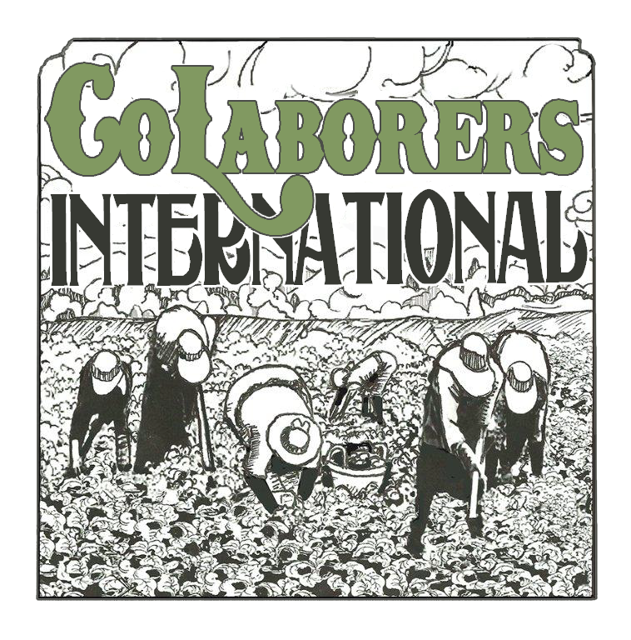

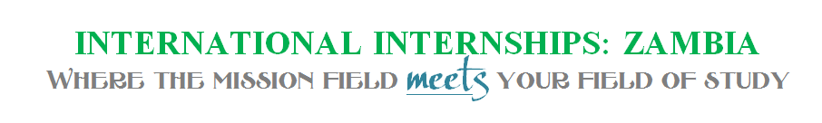
CoLaborers International assists indigenous-led groups abroad in serving their own communities while connecting U.S. college students with opportunities to serve in their field of study with these groups.

International internships are total immersion with in-country indigenous leaders. Interns are housed at international project locations or homestays. They eat their meals with staff and communities they serve. They have the opportunity to serve alongside indigenous leaders and to use their skills with a missions emphasis.
As an intern, you have the opportunity to put your field of study into practice and increase your cultural understanding. In Zambia, you will be working alongside indigenous leaders to serve homeless youth and low income families in the community. Youth are adolescent – late teenage age range and predominately male.
Interns receive:
- Academic credit as approved by university
- Recommendation letters

- Certificate of Completion

INTERNSHIP APPLICATION
Internship Preferences (highlight all that apply):

  - Administration
  - Athletic Ministry
  - Creative Arts (music, dance, drama, art)
  - Biblical Studies / Missions
  - Business as Mission
  - Elementary Education
  - Film
  - Financial Planning
  - Graphic Design & Mixed Media
  - Humanitarian Aide
  - Intercultural / Global studies
  - Marketing / PR
  - Psychology
  - Resource & Project Management
  - Social Work
  - Youth Ministry

Student Information
Name (first, last): ____________________________________________Gender:__________________
College / University Name: __________________________________
Campus Address: _________________________________________
City: ____________________________________________________ State: ______________
Zip: ________________________Phone: ______________________
Email: _______________________________________________
Date of Graduation: ____________________________Major: ______________________GPA: _____________

When would you like to do your internship? Summer 20____

Short Answer (attach)
What do you hope to gain through an internship with CoLaborers International?
What skills can you contribute? What relevant experience do you have?
How comfortable are you with participating in the Bible studies that are a part of this program’s outreaches? Are you a Christian?
Have you travelled abroad before? If so, list dates and purpose of travel.
How does this experience fit with your vocational goals?
Do you have any chronic physical or mental health concerns?

Signatures of Approval

Student _________________________________________________Date __________________

Academic Advisor ________________ _______________________ Date ____________________

College/ University Internship Director________________ _______________________ Date _________________

CoLaborers Intl Internship Director ________________ _______________________ Date __________________

Please provide at least 3 non-related references.

Name:
Connection to you:
Phone:
Email:

Name:
Connection to you:
Phone:
Email:

Name:
Connection to you:
Phone:
Email:

ZAMBIA TIMELINE
July Annually | 27 Mungulube Road, Lusaka Zambia

All applicants are required to fill out the application, provide 3 references for contact, to complete a mental health questionnaire and to attend cultural training prior to departure and mental health debriefing upon return. Vaccinations may be required.
FINANCES
Donations to your internship cost are tax deductible when made out to CoLaborers International
Optional medical insurance information is provided and may be purchased if desired. Scholarships are available (partial) and applications can be given upon request. Initial deposit toward plane ticket cost due by end of February. Remaining finances due by May 31^{st.}

TBA (5 hours) Zambia Cultural Training
Conducted by David Stuebing

- Overview of Zambia’s national history and formation
- Language – greetings, customs and praise songs in 5 major tribal languages: Bemba, Tonga, Lozi and Nyanja
- Cultural views of money and personal items
- Role-play shopping, haggling and greetings
- Food Customs
- Physical Contact, body language and clothing
- View and role of time
- Zambian weather in July (dry season)
- Lusaka Statistics
- Introduction to Chisomo Centers in Zambia
- Safety & behavioral standard contract
- Questions & Answers
- Luncheon

Before Departure
Required Reading:

- Foreign to Familiar by Sarah A. Lanier
- Welcome Packet by
CoLaborers International

Mid Term Break:
Travel from the Chisomo Centers in capital city of Lusaka to Livingstone and to Botswana with Zambian chaperones. Activities include:
- River Safari from Livingston, Zambia to Chobe River, Botswana
- Jeep Safari in Chobe National Park, Botswana
- Victoria Falls in Livingston, Zambia

TBA Debriefing Retreat
- Individual Debriefing: Terra Tuono- Shell, LCPC
- Individual and group sessions and group wrap-up
- Re-entry discussion: Melissa Stuebing, MHA
- Devotional, recognizing culture shock, tips
- Closing luncheon

