

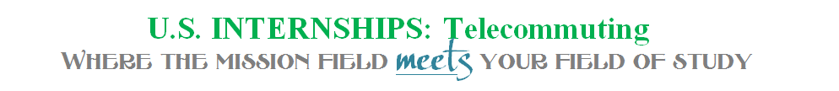

CoLaborers International assists indigenous-led groups abroad in serving their own communities while connecting U.S. college students with opportunities to serve in their field of study with these groups.
U.S. internships are available for telecommuting. Interns have a weekly one-on-one video chat with their supervisor for review of weekly assignments, topic discussions and resources for upcoming assignments. Interns follow a weekly syllabus or work on specific projects, log their hours and have the benefit of knowing that the projects they work on directly connect with current needs abroad.
Interns receive:
- Academic credit as approved by university
- Recommendation letters
- Certificate of Completion
INTERNSHIP APPLICATION
Internship Preferences (highlight all that apply):

  - Administration
  - Non Profit Development
  - Film
  - Financial Planning
  - Graphic Design & Mixed Media
  - Marketing
  - Public Relations
  - Psychology Research
  - Resource Coordination
  - Project Management

Student Information
Name (first, last): ____________________________________________Gender:__________________
College / University Name: __________________________________
Campus Address: _________________________________________
City: ____________________________________________________ State: ______________
Zip: ________________________Phone: ______________________
Email: _______________________________________________
Date of Graduation: ____________________________Major: ______________________GPA: _____________

Short Answer (attach)
What do you hope to gain through an internship with CoLaborers International?
What skills can you contribute? What relevant experience do you have?
How does this experience fit with your vocational goals?

When would you like to do your internship? Fall 20___ Spring 20___ Summer 20___

Signatures of Approval

Student _________________________________________________Date __________________

Academic Advisor ________________ _______________________ Date ____________________

College/ University Internship Director________________ _______________________ Date _________________

CoLaborers Intl Internship Director ________________ _______________________ Date __________________

Please provide at least 3 non-related references.

Name:
Connection to you:
Phone:
Email:

Name:
Connection to you:
Phone:
Email:

Name:
Connection to you:
Phone:
Email:

